Random Scan Display:
Random Scan System uses an electron beam which operates like a pencil to create a line image on the CRT screen. The picture is constructed out of a sequence of straight-line segments. Each line segment is drawn on the screen by directing the beam to move from one point on the screen to the next, where its x & y coordinates define each point. After drawing the picture. The system cycles back to the first line and design all the lines of the image 30 to 60 time each second. The process is shown in fig:
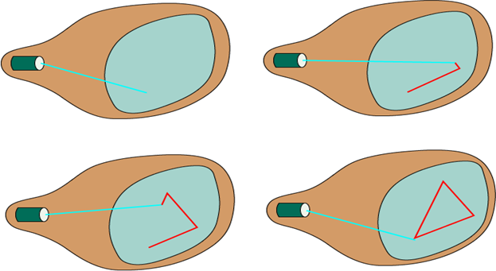
Random-scan monitors are also known as vector displays or stroke-writing displays or calligraphic displays.

Advantages:
- A CRT has the electron beam directed only to the parts of the screen where an image is to be drawn.
- Produce smooth line drawings.
- High Resolution

Disadvantages:
- Random-Scan monitors cannot display realistic shades scenes.

